BYRAM SWINGING BRIDGE FESTIVAL
BOOTH APPLICATION

April 28, 2023 (6:00 pm to 11:00 pm) and April 29, 2023 (12:00 pm to 11:00 pm)
7557 South Siwell Road, Byram, MS 39272

Vendor’s Name:

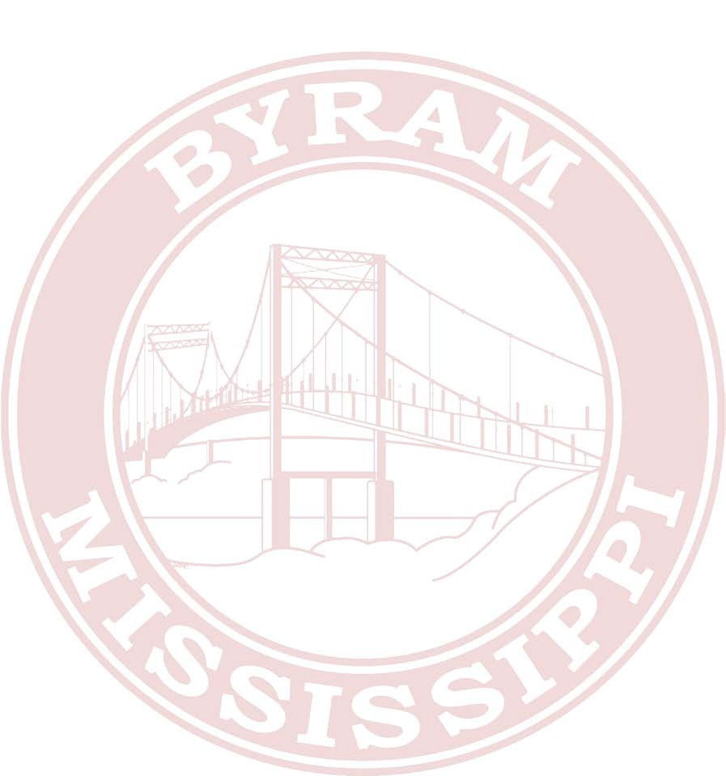
Contact Person:

Mailing Address:

City, State & Zip Code:_

Daytime Phone Number:

Email Address:

Detailed Description of items to be sold:

BOOTH FEES

Number of 10’x10’ booths (no electricity) Number of days $50.00 per booth for weekend, $35.00 per day $
Electricity (110 volt only) is an additional $25.00. Please list equipment to be using electricity

Generators are allowed – But must be the quiet ones.

Total Amount Due: $

CHECKLIST
Application Form
Check for Booth Fee (Payable to Byram Swinging Bridge Festival)
Proof of Liability Insurance (Food Vendors Only)

General Release
The undersigned does hereby and forever discharge the City of Byram, Byram Chamber of Commerce as well as any and all private land owners of and from all manner of actions, suits, damages, claims, and demands whatsoever in law or equity from any loss or damage to the undersigned’s property while in the possession, supervision or auspices of the City of Byram, and any and all private land owners, their agents, representatives or employees. The undersigned has reviewed the attached vendor’s regulations and map and is aware of new changes to layout and the undersigned agrees to comply with all rules set forth by the City of Byram, and any and all private land owners. Refunds will not be given under any circumstances.

Applicant’s Signature Date

Please Mail by April 14, 2023, to:
City of Byram, Attn: Byram Swinging Bridge Festival, P. O. Box 720609, Byram, MS 39272. Check out our Facebook page for more information.

